# Diabetes Classification Results using SVC

## Classification Report:

precision recall f1-score support  
  
 0 0.79 0.72 0.75 149  
 1 0.74 0.81 0.77 151  
  
 accuracy 0.76 300  
 macro avg 0.77 0.76 0.76 300  
weighted avg 0.77 0.76 0.76 300

## ROC AUC Score:

ROC AUC Score (SVC): 0.8297257655895818

## ROC Curve:

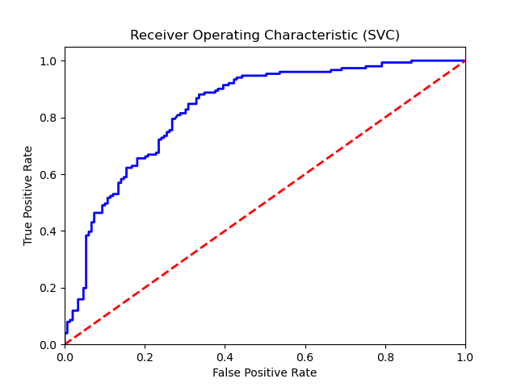

## Confusion Matrix:

True Negatives: 107

False Positives: 42

False Negatives: 29

True Positives: 122

## Confusion Matrix Plot:

